Requirements caB2B milestone

Path Curation and Query enhancements 3
Overview 3
Selected paths 3
Path curation across models 3
Process to be followed 5
Changes in search data wizard 5
Online creation and usage of categories 6
caArray 2.0 data access 6
caArray 2.0 performance based access 6
Ability to query secure data services 7
Use cases to detail out the required APIs 7
Multiple browser support 9

Path Curation and Query enhancements

Overview
In general, there are several possible paths to connect a set of entities. But typically only a few of these possible paths will be meaningful. caB2B’s path-curation module enables the curator (typically, the administrator) to define which paths are “meaningful” (according to the curator) for a given set of entities.
Such a set of paths that connect a set of entities meaningfully is called a curated path. Curation significantly reduces the effort needed by the end-user to build a query. The end-user is guarded from the painstaking process of wading through several paths trying to find the ones that are meaningful. For example, the auto-connect feature will utilize the curated paths to connect all the entities present in the query.

Selected paths
Curated paths effectively filter out paths that are not/as meaningful and thus act as a first level filter. In some cases it may be seen that some of these curated paths are used most often; in such a case, the curator may mark such curated paths as selected. Selected paths are thus a second-level filter that can be used to further reduce the effort needed by the end-user. Thus path curation involves defining curated and selected paths.

Path curation across models
The concept of path curation can also be extended for defining paths across different models. Currently caB2B allows path across models, only when the two classes (from different model) have same concept codes (matched in order) AND one attribute from each class has same concept code (matched in order). The matching attribute is used in joining and the classes are end points of that inter-model bridge. Based on our experience, this check is too restrictive in the real world. This is due to the fact that most models not fully semantically interoperable (e.g. attributes are reused but not class, attribute, and value domain). Due to these issues, even though some applications which actually “may” interoperate, are not allowed to do so. In the new requirement of path curation, existing functionality will be extended to accommodate such joins across models not sharing CDEs.

Use Cases for CDE non-reuse
- Semantics (DEC/attribute reuse but not CDE reuse)
- caTissue Core and caTIES : The “Accession” (caTIES) and the “Specimen Collection Group” (caTissue).

- Genomic Identifiers
caBIO and Genomic Identifier CDEs
TrAPSS and Genomic Identifier CDEs
- Metadata stored in data versus static modeling (Abstraction)
- caArray 2.0: Array design metadata is stored as data
- BRIDG and caTissue Suite Clinical Annotations
  - Lab values modeling are generalized.
  - Compare this to the following CDEs where a lab value (PSA) is modeled more statically :
CDE Public ID: 3769
CDE Public ID: 65065
CDE Public ID: 2475190
CDE Public ID: 2475191

Inevitably, due to the way ISO created the 11179 specification, in many cases partial CDE reuse (DEC reuse or reuse of attribute) occurs. The VCDE workspace has identified many more cases during compatibility reviews. In fact, the norm is non-reuse than reuse as Silver-compatibility did not require CDE reuse. While some of this will be addressed with Gold-compatibility, caB2B needs to be more agile in traversing CDEs that are semantically the same to end users but are different CDEs due to the concept codes used or due to the way they were modeled. Here is an example:
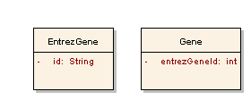

Here EntrezGene.id = Gene.entrezGeneId, but these would result in two CDEs being created. The current caB2B requirement would address this issue and allow these disparate models to interoperate seamlessly. The current requirements are leading to more complex future requirements where simple transformations such as the following may be curated by the Administrator:
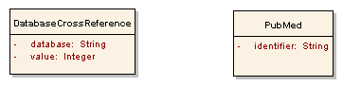

Here if DatabaseCrossReference.database=’PubMed’ (NOTE that concept code for the ‘PubMed’ permissible value must be the same as for semantic annotation of second class called PubMed), then DatabaseCrossReference.value=PubMed.identifier.

Process to be followed
In curating path across two models, the curator must add the classes, which will be the end points of inter-model bridge, in the DAG. Ways to connect these two ends of the bridge will be found by following the process. In the process, each successive step is reached only if no results are found in the previous step.

Step 1: In models from caDSR, public ID is defined only for attributes. An attribute’s public ID is same as the Data Element public ID from the CDE browser. The application should show exact common data element (CDE) matches e. g. application should show attributes which belongs to bridge classes and which have the same public ID.

Step 2: Show exact data element concept (DEC) match. Ideal way of doing this is matching their public ID. As these public IDs are absent in XML, this should be simulated by matching the concept codes of attribute and class (not value domain) in order. If they match, that attribute is eligible for joining. This is the current behavior of caB2B.

Step 3: Show attributes having same concept codes in the same order (i.e. property and property qualifier concept codes are in the same order).

Step 4: Show all attributes of bridge classes and ask the Administrator to select attributes to be used to join.

In all of the above steps, if multiple attributes are matched / chosen as bridge, they should be treated as a single path. Currently, they are treated as multiple paths. Currently, they are treated as multiple paths.
This feature needs additional support from DCQL to joins using multiple attributes, currently only single attribute joins are supported.

Changes in search data wizard
When end-user attempts to connect a pair of classes in search data wizard
- If selected paths exist, they can be directly applied without popping up the ambiguity resolver.
- If there are curated paths, but no selected paths, then the ambiguity resolver will pop up showing all curated paths and a link to get all possible paths.
- If there are no curated paths, the ambiguity resolver will pop up showing all possible paths. If both classes are from different models, then the above mentioned steps will be followed to allow the user to choose needed attributes to be used while joining. The difference is, even if there are matches found in step 1,2 or 3, the end user may always override those and use step 4 to define a custom join.

If user selects multiple classes (>1) and then uses auto-connect,
- If selected paths exist, they may be directly applied without popping up the ambiguity resolver.
- If there are curated paths, but no selected paths, then the ambiguity resolver will pop up showing all curated paths and a link to get all possible paths.

Online creation and usage of categories

Once an Administrator saves a category into the database, it should be visible immediately in the caB2B client (i.e. in the metadata search call). When caB2B admin and caB2B server are pointing to same database and a category is created, it should be included in the next metadata search. Currently when category is created, it is not included in the caB2B metadata search until the server is restarted. The reason for this is, as admin and cab2b server are deployed as two different applications, there are two different instances of metadata cache. The other problem is that the current implementation takes twice the memory due to two instances of cache.

caArray 2.0 data access
The goal here is to query for data from the caArray 2.0 data service. It is a unsecured service. There are certain customizations, which are done to allow the user to query the older caArray service (v1.x) from caB2B just like any other data service.
To support caArray2.0, the following activities are required:
- Try querying caArray using default command-line client generated with the service. Fetch data for multiple objects; understand behavior of the service and the structure of results.
- Find the need for any customization. Also check the need of modifying the existing customization to meet requirement of new service.
- Integrate caB2B with the caArray service

caArray 2.0 performance based access
Certain objects from caArray are huge in number and/or size. To give user a real time performance certain customizations are to be added in caB2B. This feature involves:
- Identify objects for which the customizations are needed.
- Identify the best possible way in which the information will be most usable to the end users.
- Implement the customizations.

Ability to query secure data services
Create authentication mechanism in caB2B so that user can enter login, password and identity provider. These will be used to authenticate the user and get the proxy certificates for current session. This involves
- Developing a prototype to understand and reuse existing grid APIs for IdP based authentication.
- Developing a standalone application to query a secure service and get data.
- Integrate above two prototypes to create an authentication framework.
- Use this framework in caB2B to query any stand caGrid secure data service.
In caB2B v2.0, we have a requirement that any valid caGrid user will be able to use caB2B and query data from any grid service which allows him/her to access the data.

Use cases to detail out the required APIs
We have used the login UI from GAARDS user interface (figure 1 below) and GTS steps (figure 2 below) as reference. Let’s consider the steps involved in the authentication process
- User starts caB2B client
- caB2B will call a caGrid API which will return the list of all trusted IdPs.
- caB2B will present a “log-in” screen that provides a list of “trusted IDPs” for users to select from, along with text boxes to enter username, password
- User will choose one IdP (IdP = authentication service from GAARDS UI) and will provide username and password.
- caB2B will pass username and password to the authentication service selected by user. The service will return a SAML certificate. We are assuming each valid trusted grid IdP will have an API to cater to this requirement.
- caB2B will pass this SAML certificate to the Dorian API to get the proxy (GlobusCredential).
- caB2B stores the issued proxy in the local session for that user.
- This proxy certificate will be used for all subsequent DCQLs executed for that user in that session.
- If the password has expired, caB2B will acquire a new proxy.

For example, consider the case where, users from Washington University are made members of groups that have access to caTissue grid service data.

As soon as WashU’s IdP is trusted by Dorian, any WashU user may use caB2B to log onto the caGrid and get any secure data for which he / she has access. This will be possible without requiring additional coding/configuration to add the WashU authentication system.

The benefits of this approach are
- Any IdP, once it is trusted by Dorian, can be readily used by any caB2B client/server without any change in code, configuration etc.
- There will be no need to have a local user management system in caB2B

APIs that are needed / assumed in the above use cases:
  - caGrid API to get list of trusted IdPs
  - API on trusted IdP to get SAML certificate from username, password.
  - Dorian API to get proxy credential (GlobusCredential) by providing SAML
  - API on federated query engine to take proxy certificate (GlobusCredential).

When Dorian itself is used as an authentication service, API 2 will be present on Dorian itself
As per our understanding, the last API is already present in caGrid 1.2
These use cases are reported to caGrid as feature requests # 13405
https://gforge.nci.nih.gov/tracker/?func=detail&atid=177&aid=13405&group_id=25

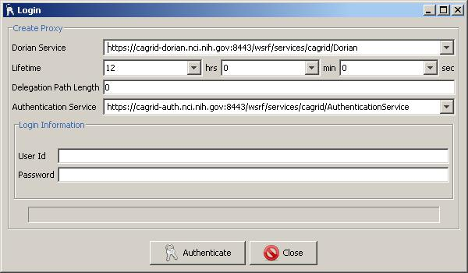

Figure 1 : GAARDS login UI

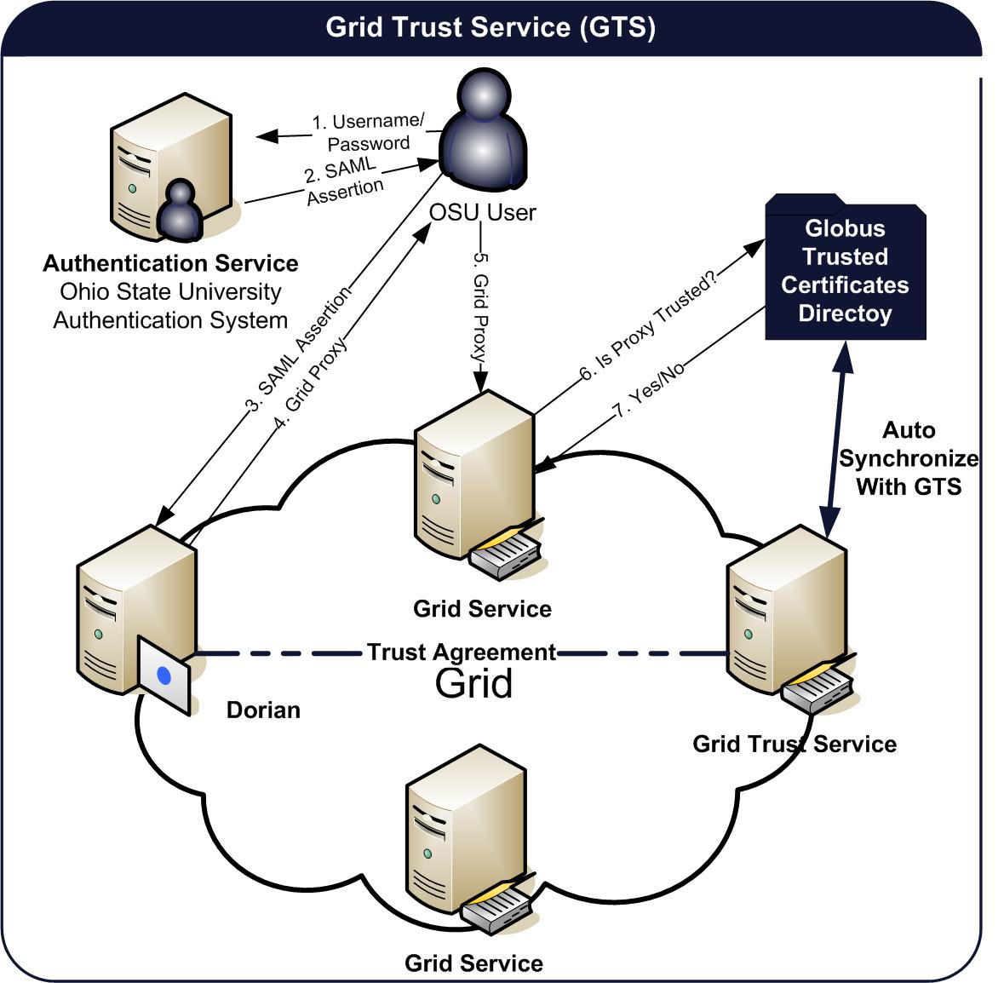
Figure 2 GTS steps

Multiple browser support
Admin module should work seamlessly at least one browser on Windows (Vista/XP/Server 2003) and Mac OS X and Linux.

